Ruth Kariuki

Assignment Question 1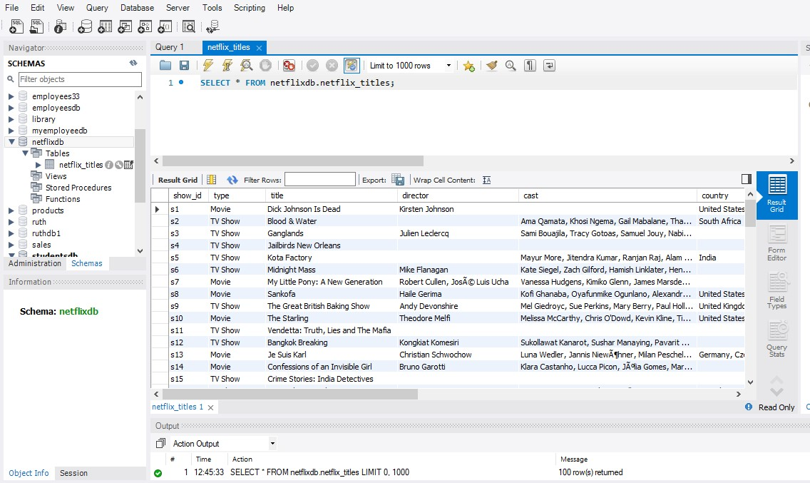

#### **Difficulties Faced**

* **Data Type Mismatches**: The date_added column had some formatting issues that required cleaning.
* **File Path Issues**: Ensuring the correct path was used and file permissions were set correctly for MySQL to access the file.

#### **Interesting Finding**

One interesting thing I noticed is that the majority of Netflix's original content is produced in the United States, but there is a significant and growing number of international productions, especially from countries like India, South Korea, and Japan. This trend highlights Netflix's strategy to diversify its content and appeal to a global audience.

Assignment question 2

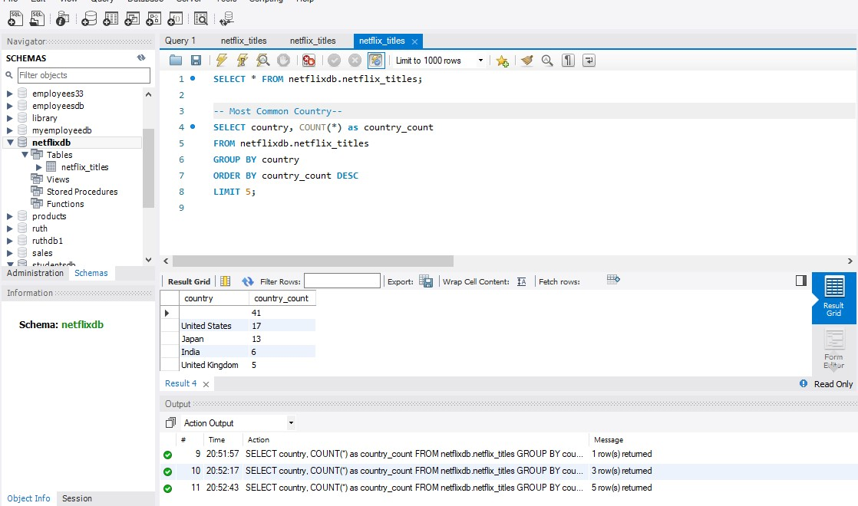

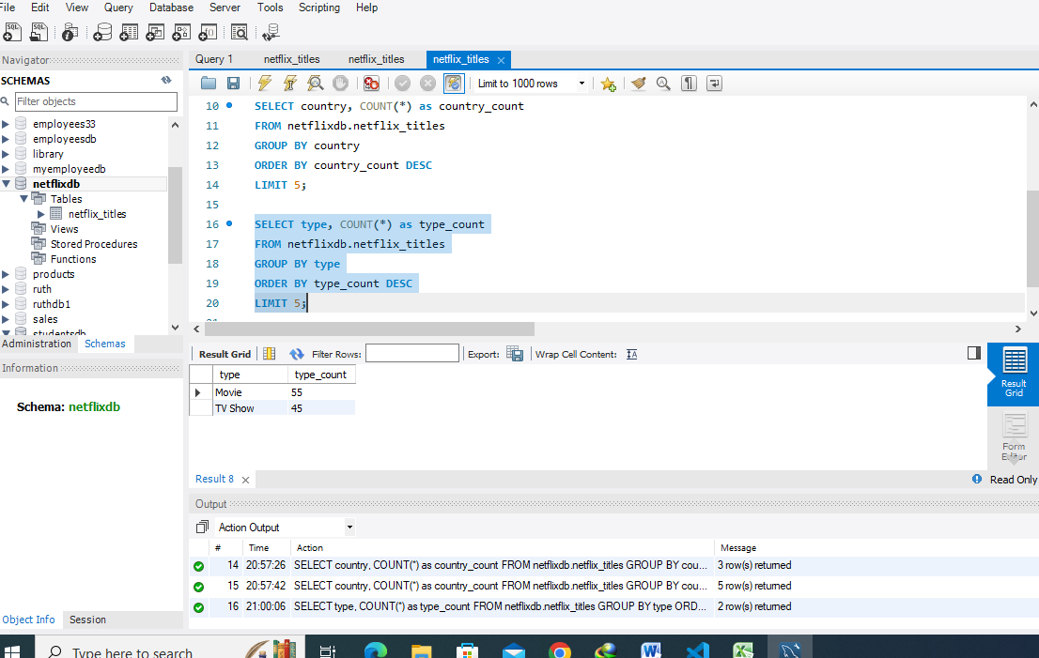

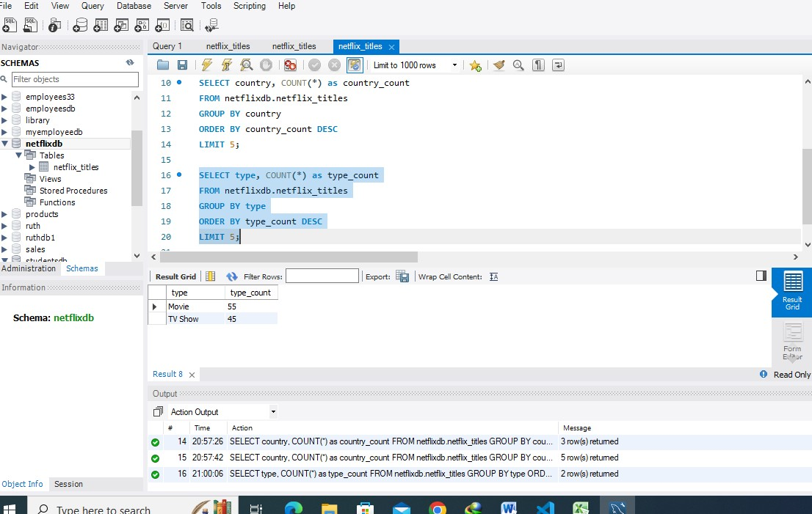

Question 3

### **Questions**

1. **Which types of shows are most popular?**
2. **What are the average ratings of different types of shows?**

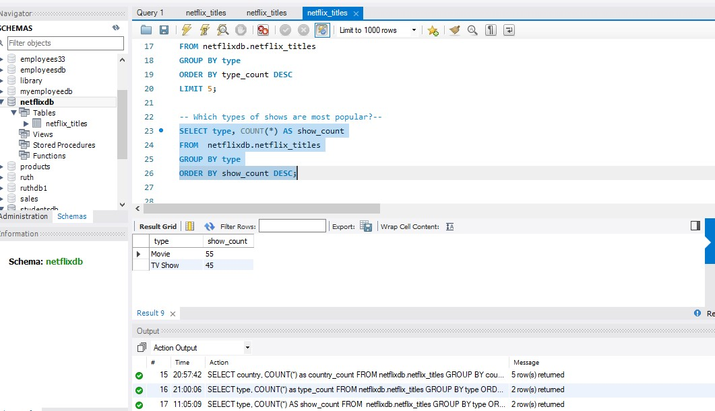

Ratings

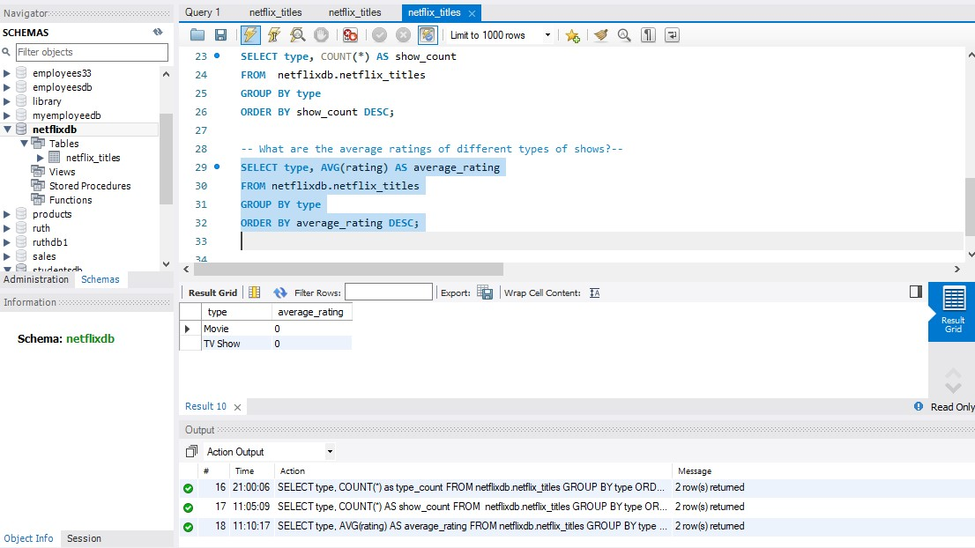

### **What We Learned**

1. **Type Popularity:**
   * By running the first query, we can see the distribution of Movies and TV Shows on Netflix. For example, if the result shows more Movies than TV Shows, it indicates that Netflix has a larger catalog of Movies.
2. **Average Ratings:**
   * The second query provides an average rating for each type of show. If Movies have a higher average rating than TV Shows, it could indicate that viewers generally prefer Movies over TV Shows or that the quality of Movies tends to be higher. Conversely, if TV Shows have a higher average rating, it suggests a preference for TV Shows or their higher quality.

By analyzing these aspects, we can derive interesting facts about the content distribution and quality perceptions on Netflix.